SKR GOVT DEGREE COLLGE
Gudur,SPSR Nellore


STUDENT INDUCTION PROGRAMME
2022-2023
DATE : 29/11/2022
DAY -21

Name of the Programme : Valedictory Function of Student Induction Programme
Venue : SEMINAR HALL
Date & Time : 29/11/2022 11.00 AM To 4.30 PM
Participants : Students & Staff

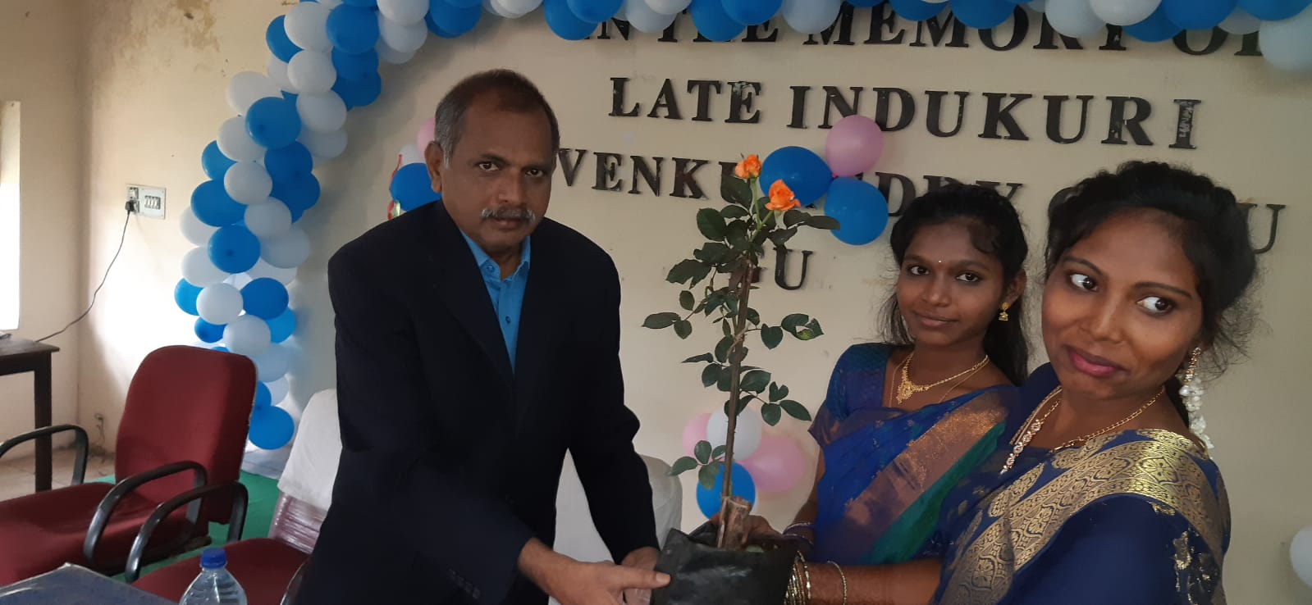
Students Inviting Principal garu on occassion of Student Induction Valedictory Programme
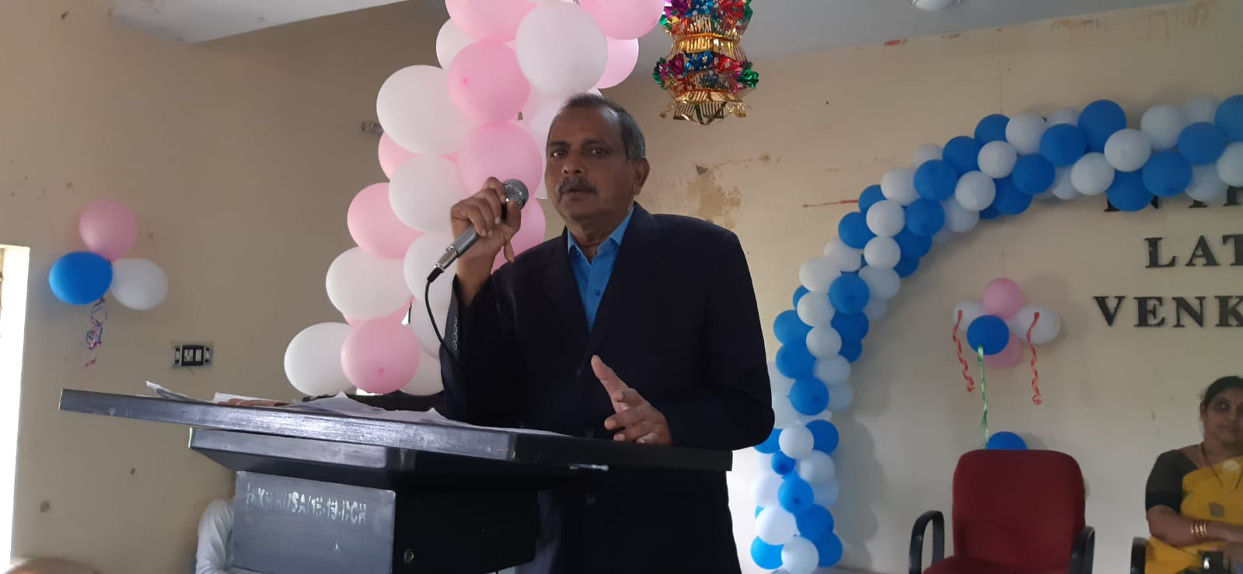
Opening Speech by Principal Dr.P.Venkateswarlu on SIP

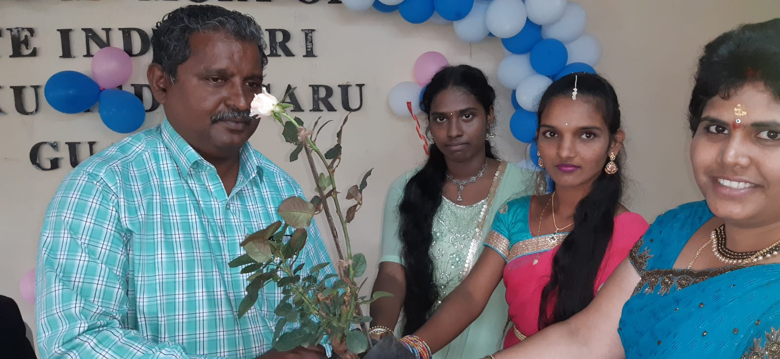
Students Inviting Vice Principal garu on occassion of Student Induction Valedictory Programme

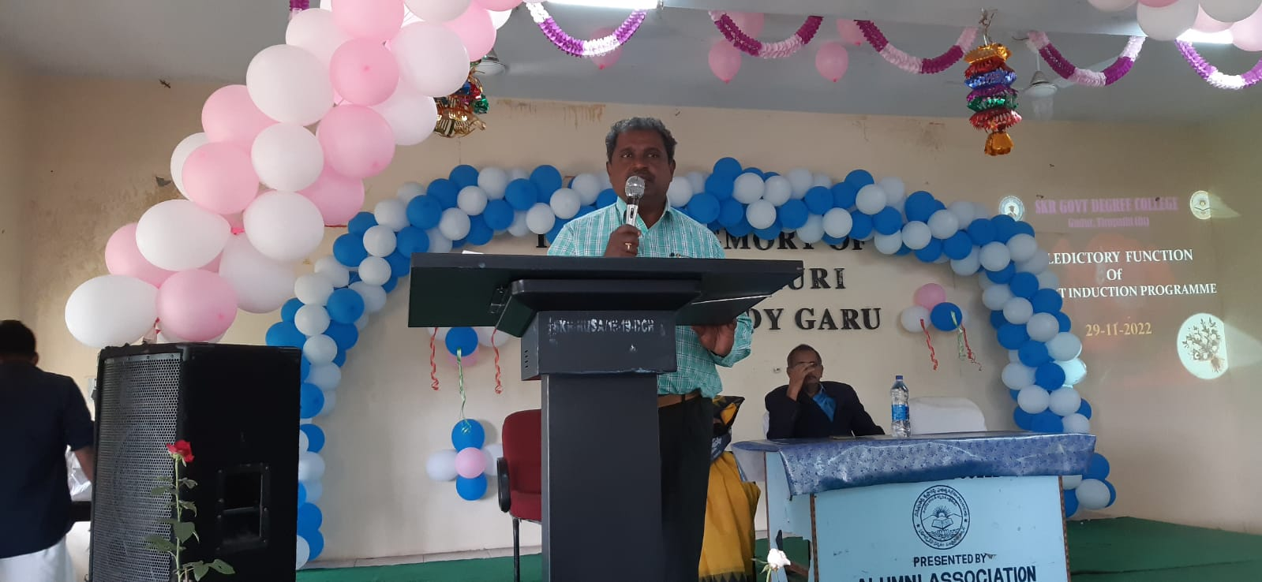
Speech by Vice Principal Dr.V.Sreenivasulu garu on occasion of SIP Valedictory

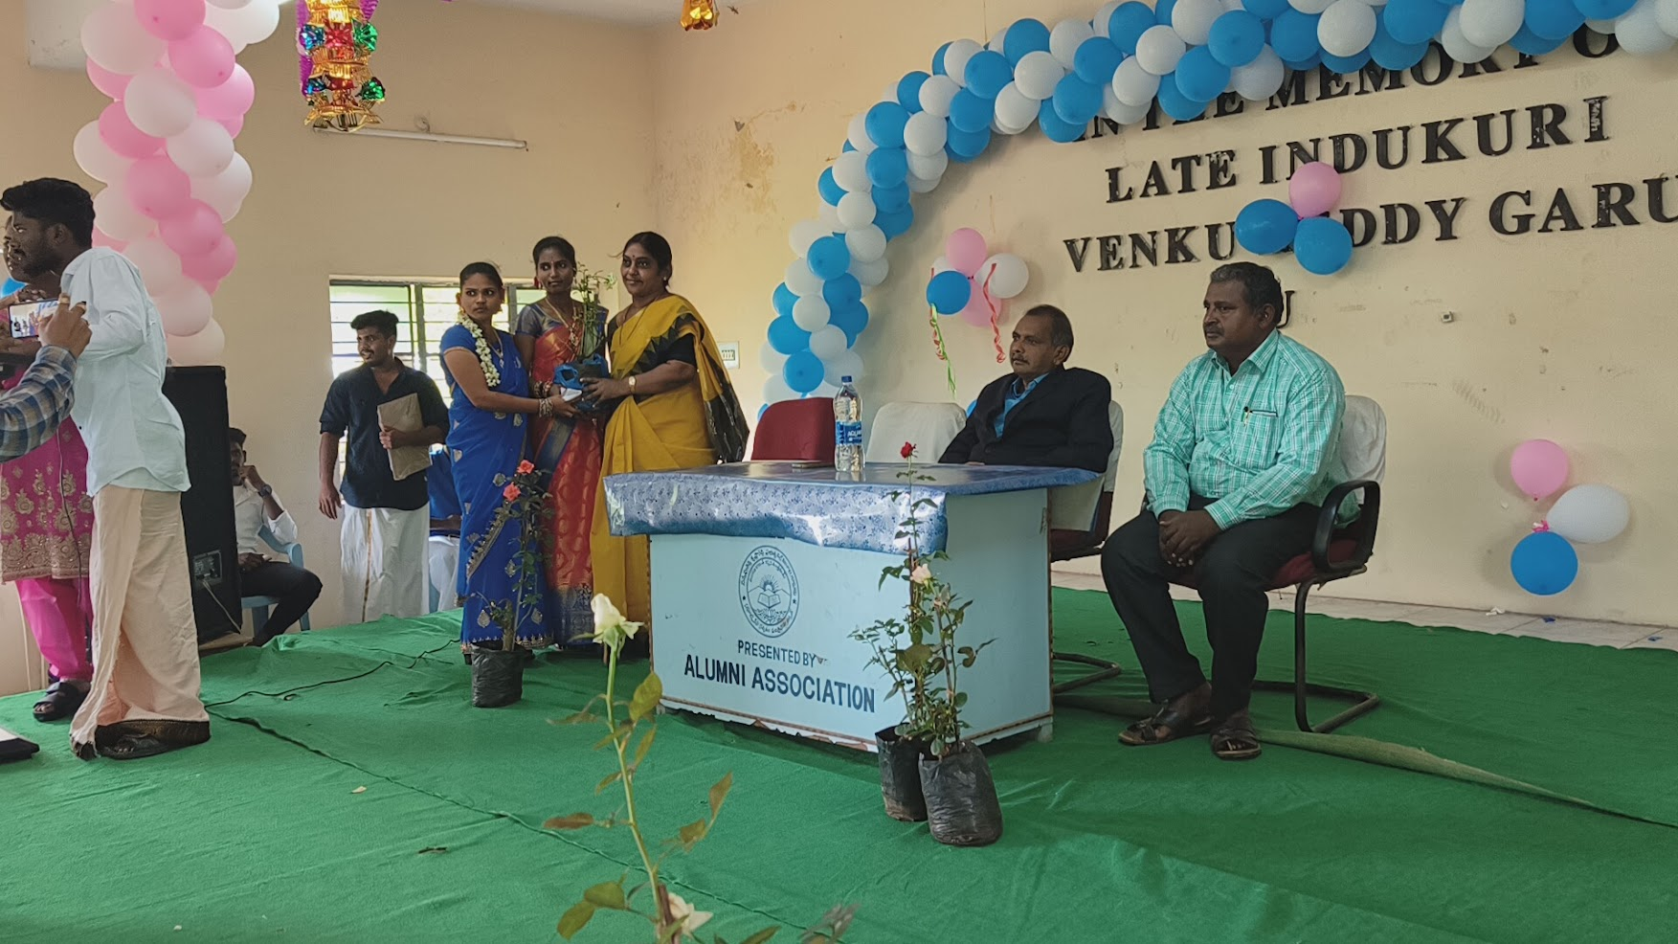
Smt S.Kiranmayee garu SIP Coordinator Invited by Students on occasion of SIP Valedictory
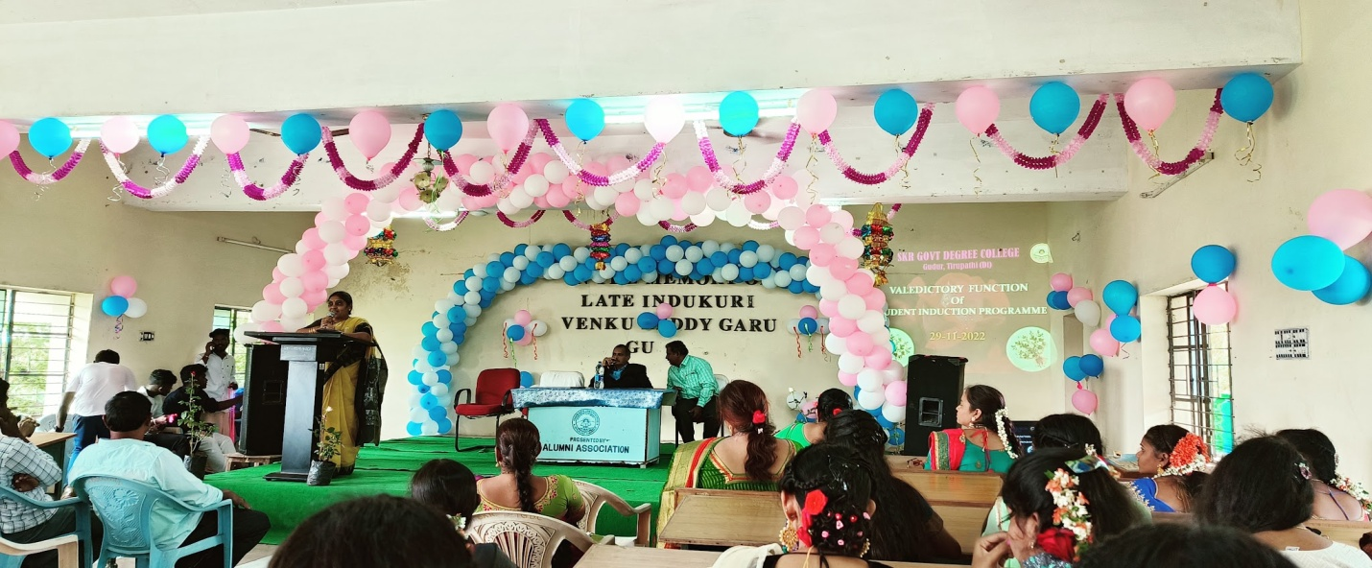
Speech on SIP by Smt Kiranmayee garu Lecturer in Mathematics
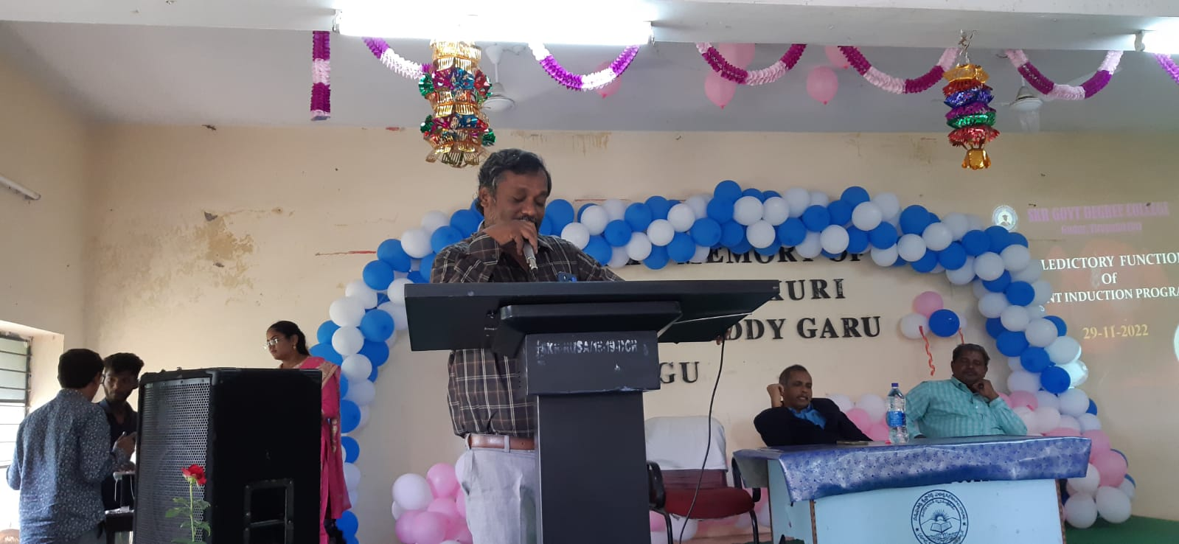
Speech on SIP Valedictory By Dr. Maqsood Ahmed garu Lecturer In Microbiology

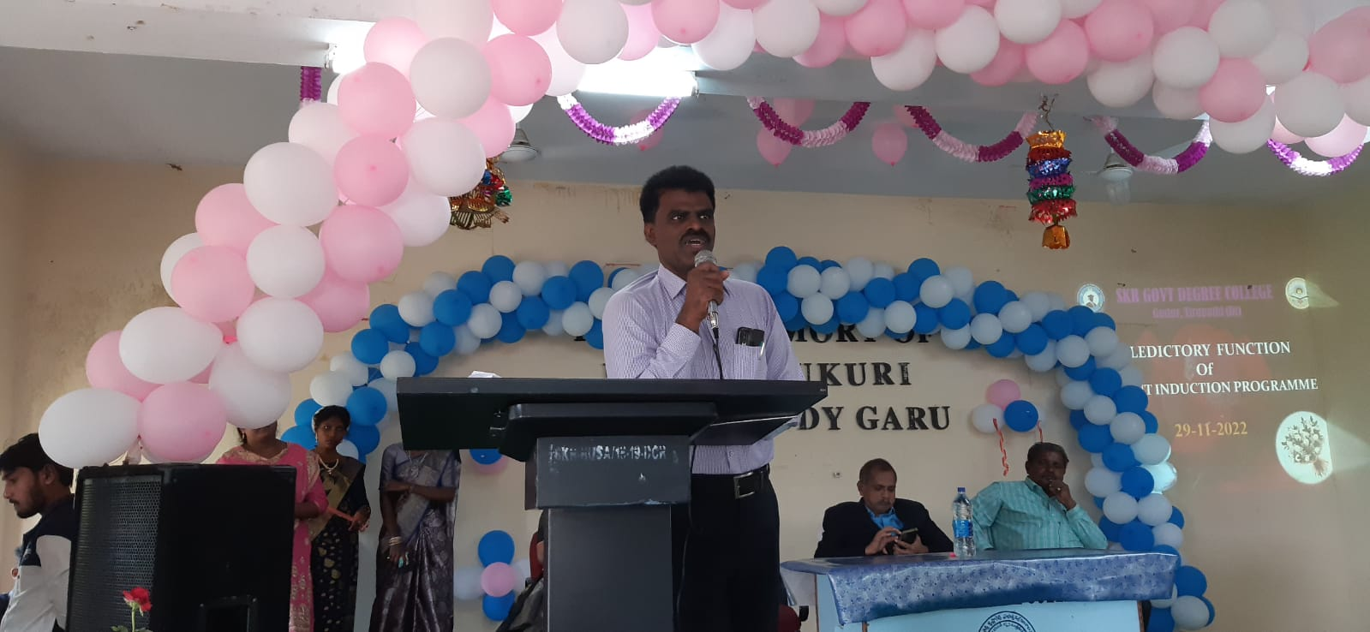
Speech on SIP Valedictory By Dr. Siva Prasad garu Lecturer In Zoology

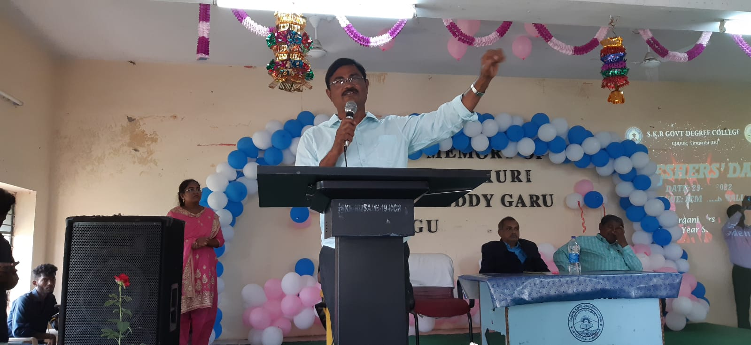
Speech on SIP Valedictory By Dr P.Narayana Raju garu Lecturer In Zoology

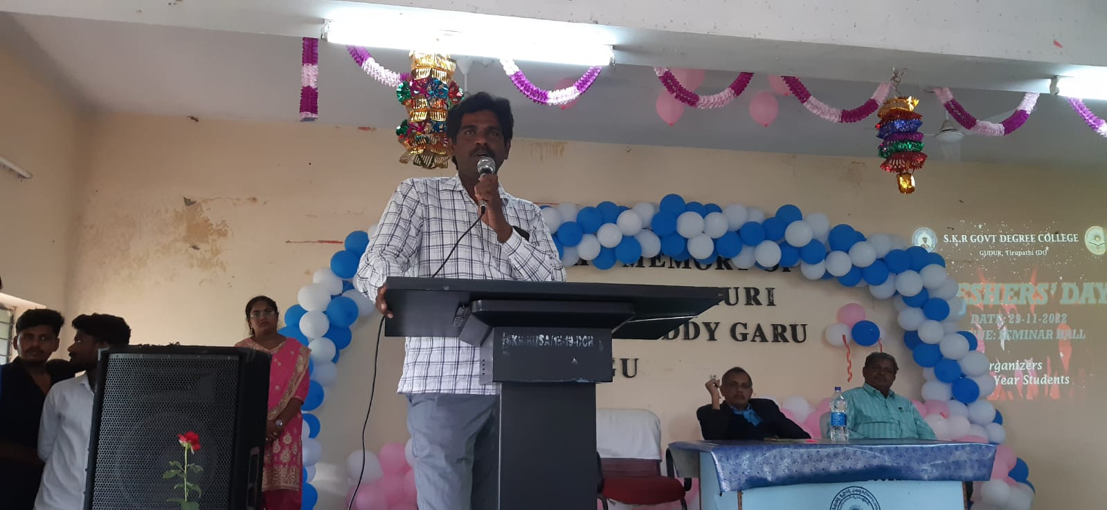
Speech on SIP Valedictory By P.S.Sreedhar Sharma garu Lecturer In Physics

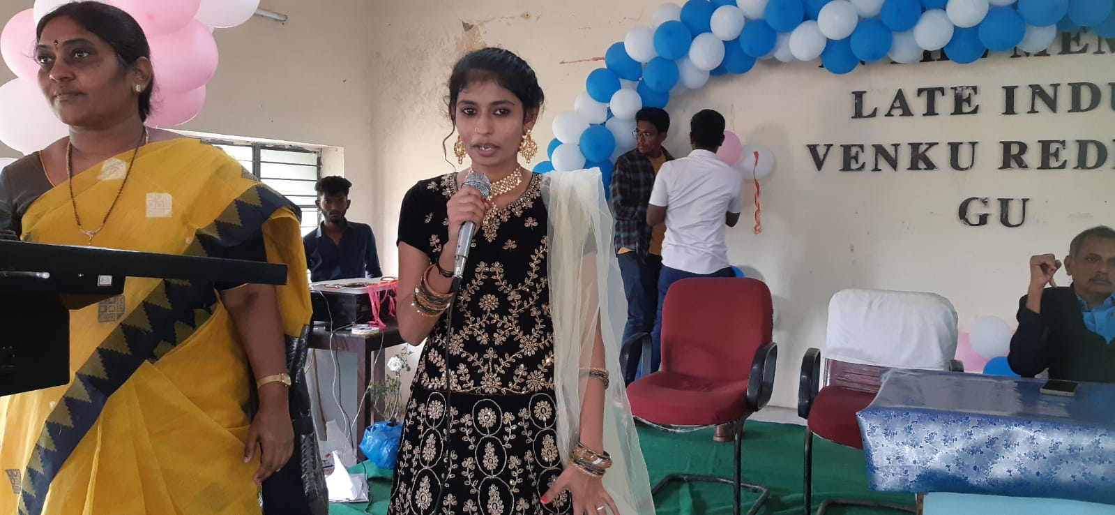
Feed Back Speech on SIP Valedictory By 1st Year Students

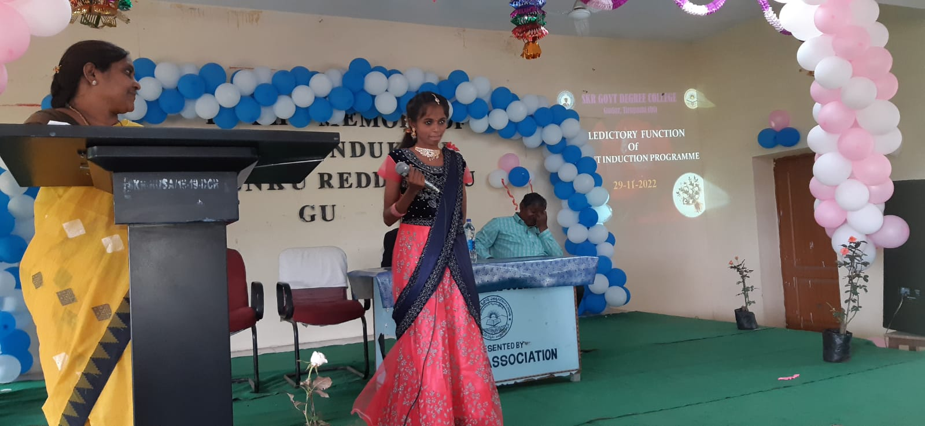
Feed Back Speech on SIP Valedictory By 1st Year Students

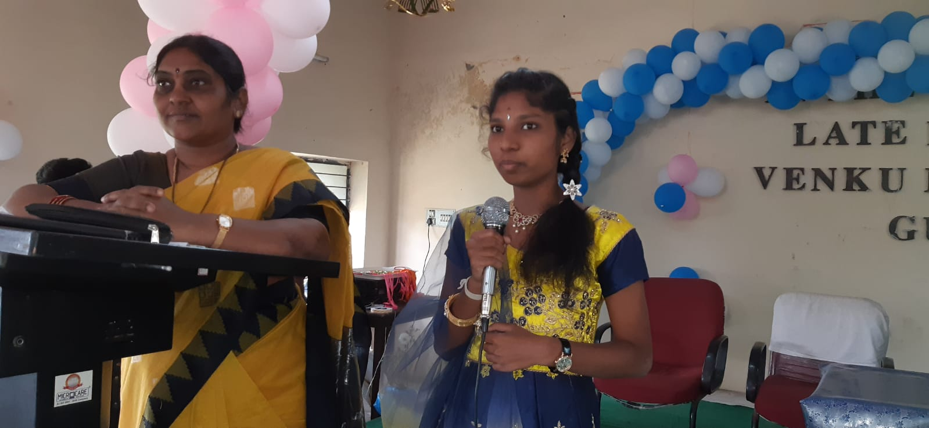
Feed Back Speech on SIP Valedictory By 1st Year Students

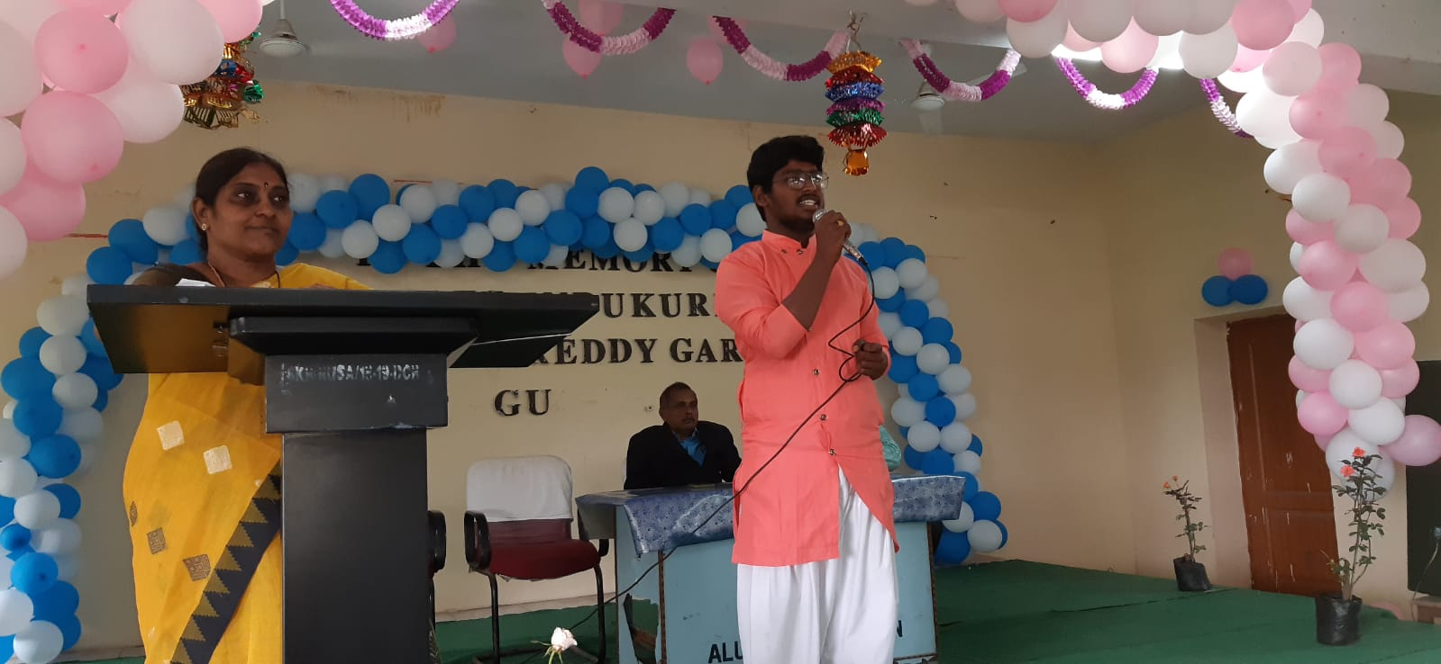
Feed Back Speech on SIP Valedictory By 1st Year Students

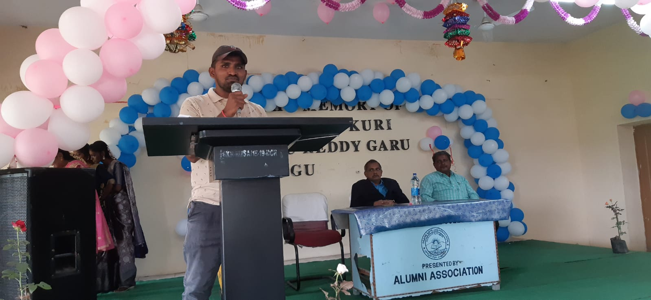
Feed Back Speech on SIP Valedictory By 1st Year Students

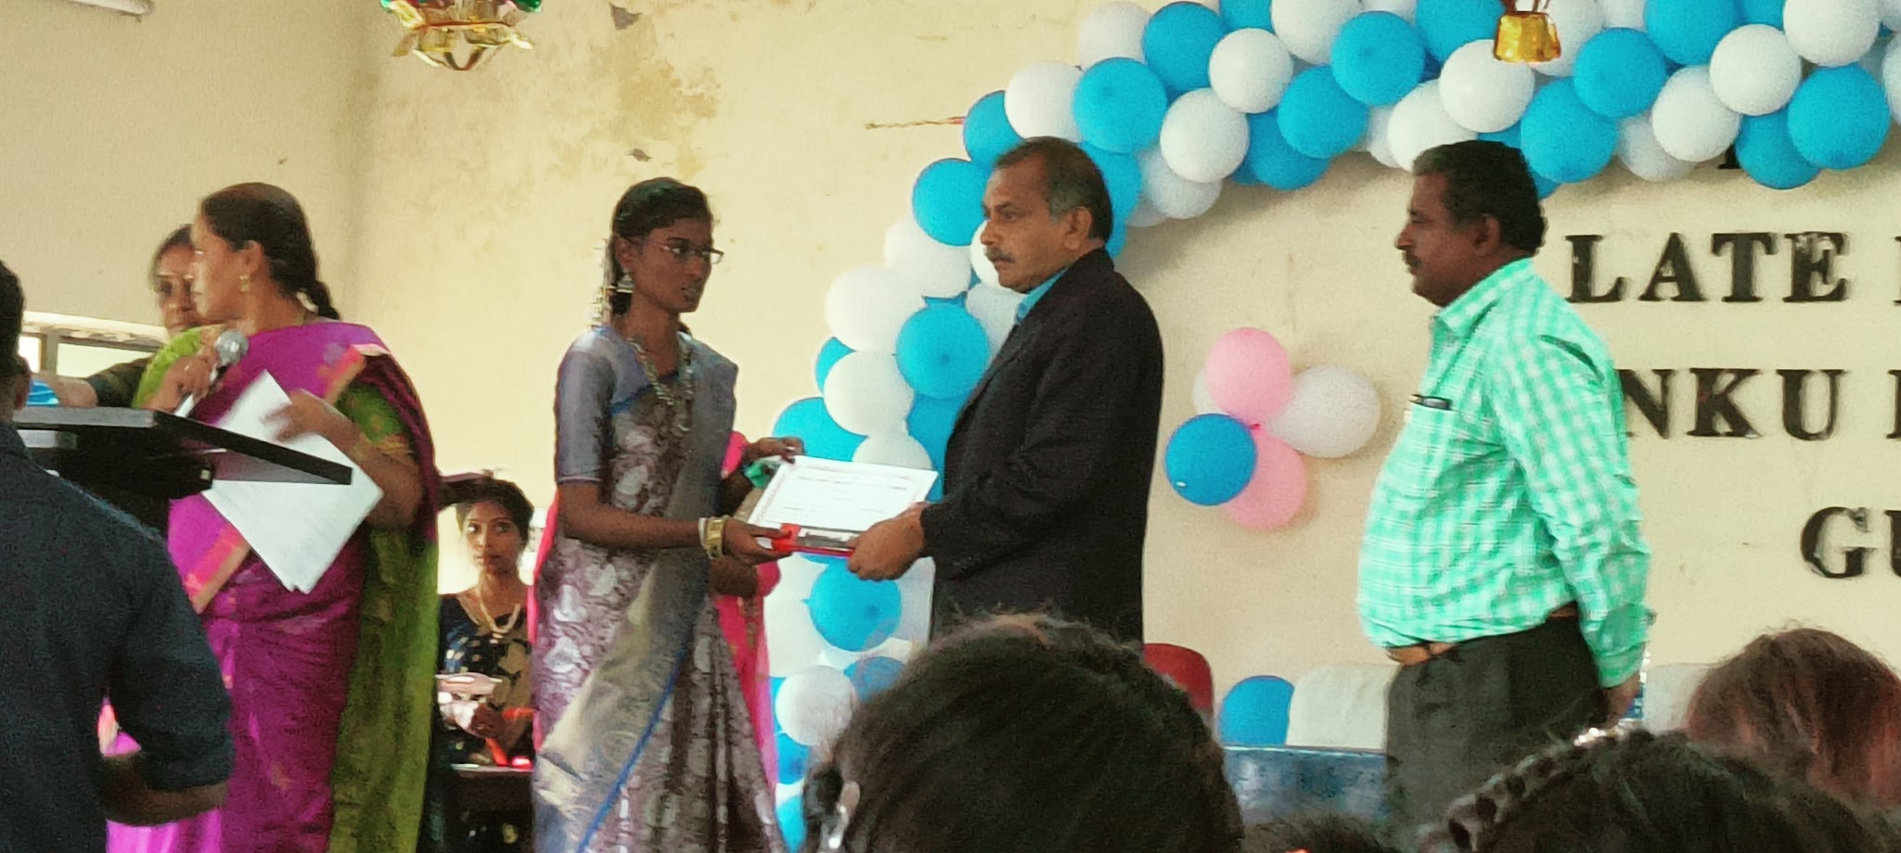
Prize Distribution by Principal garu for Meritorious Students on occasion of SIP

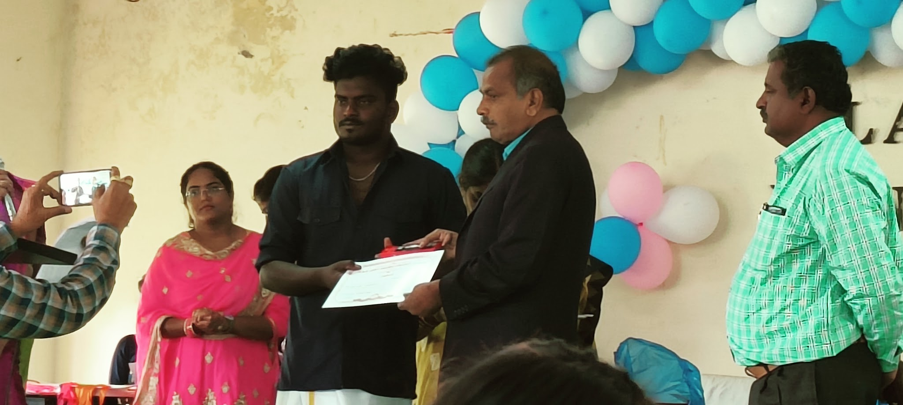
Prize Distribution by Principal garu for Meritorious Students on occasion of SIP

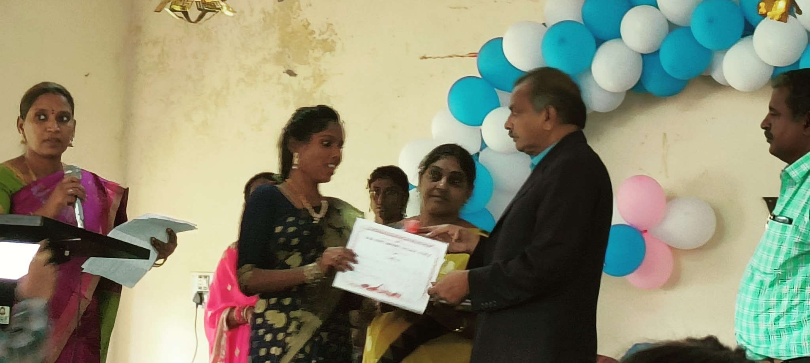
Prize Distribution by Principal garu for Meritorious Students on occasion of SIP

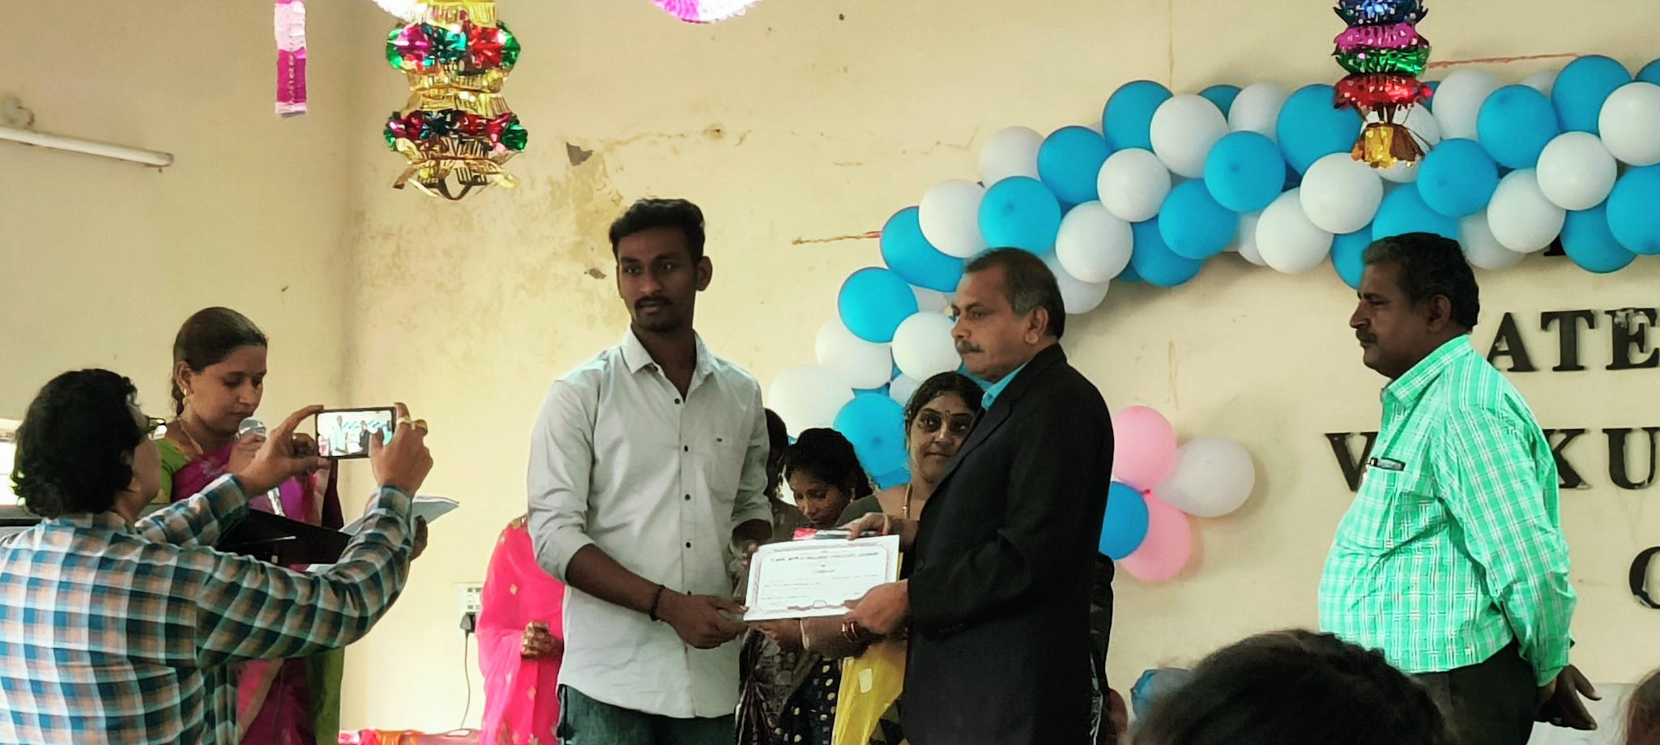
Prize Distribution by Principal garu for Meritorious Students on occasion of SIP

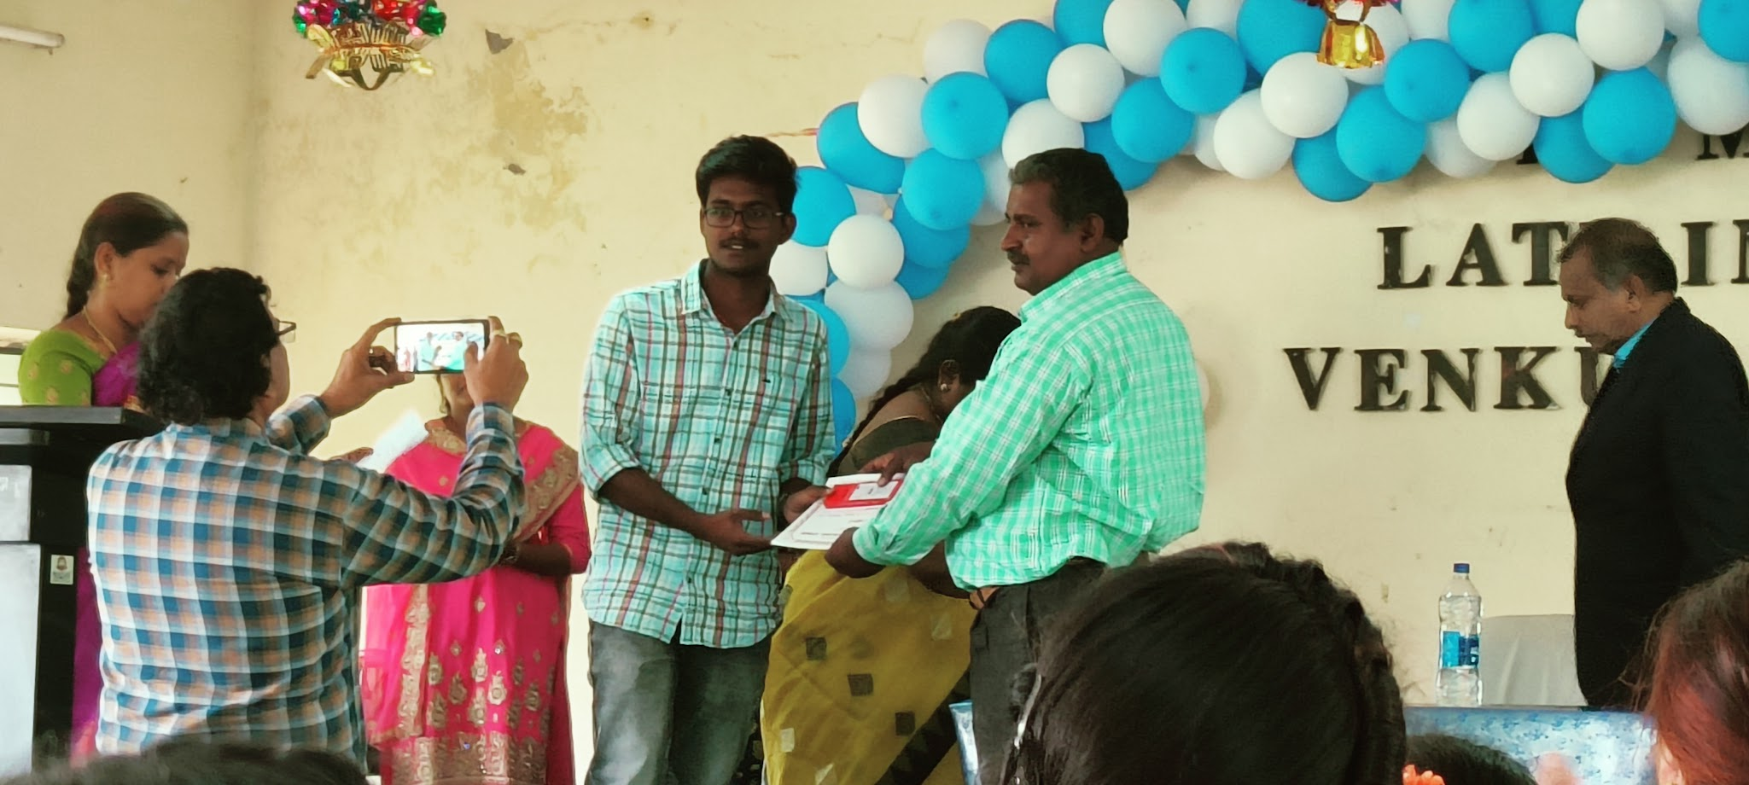
Prize Distribution byVice Principal garu for Meritorious Students on occasion of SIP

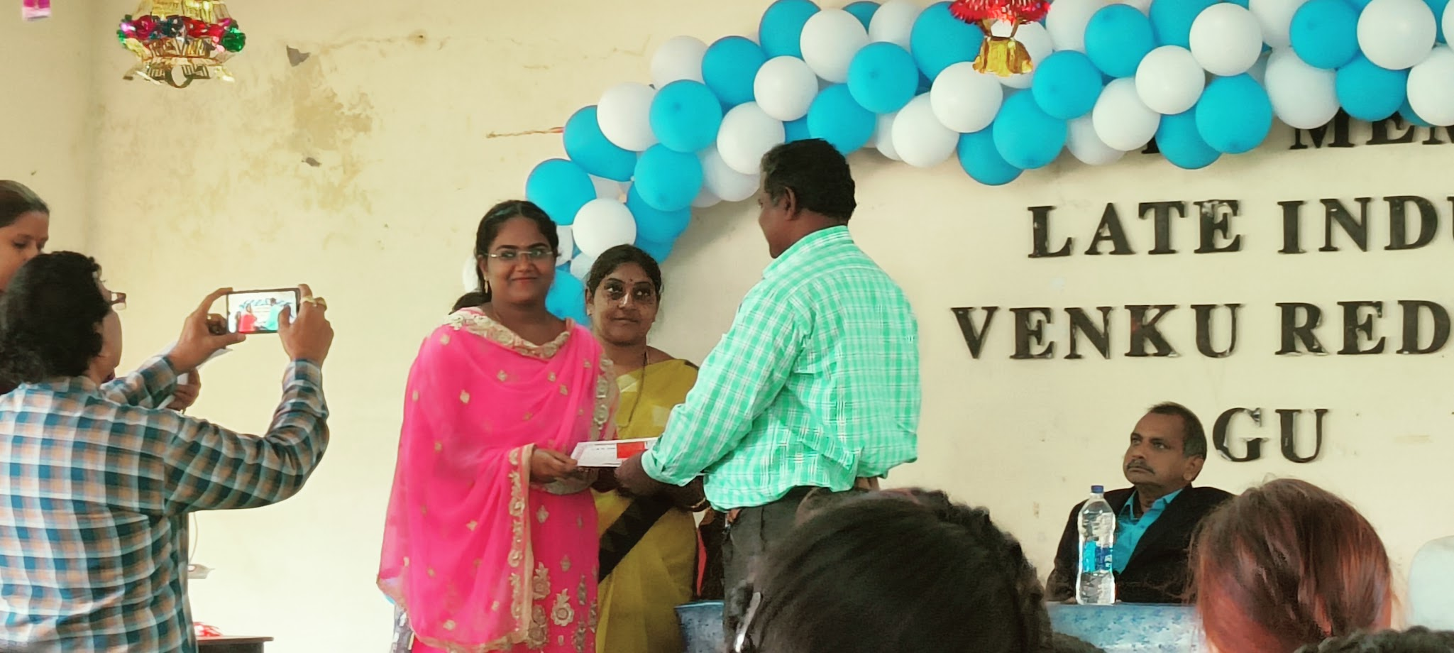
Prize Distribution byVice Principal garu for Meritorious Students on occasion of SIP

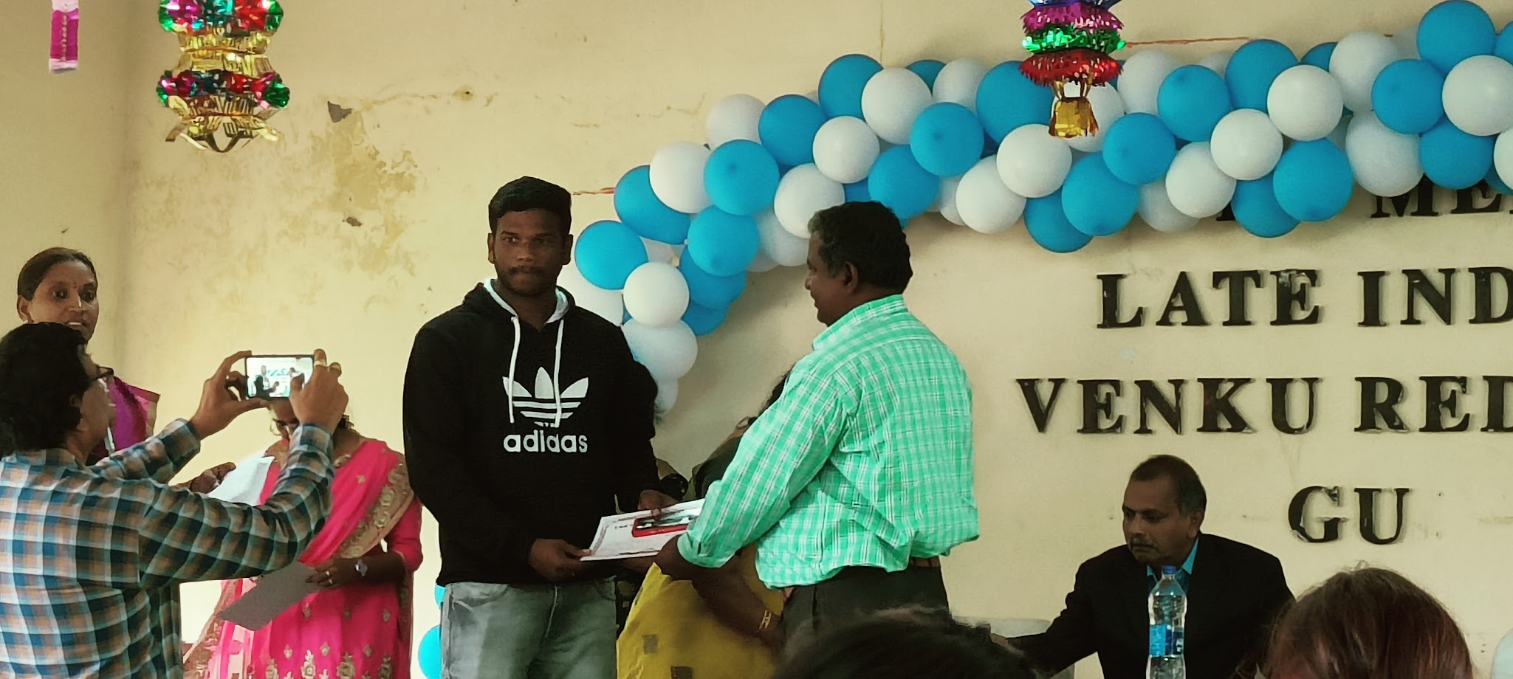
Prize Distribution byVice Principal garu for Meritorious Students on occasion of SIP

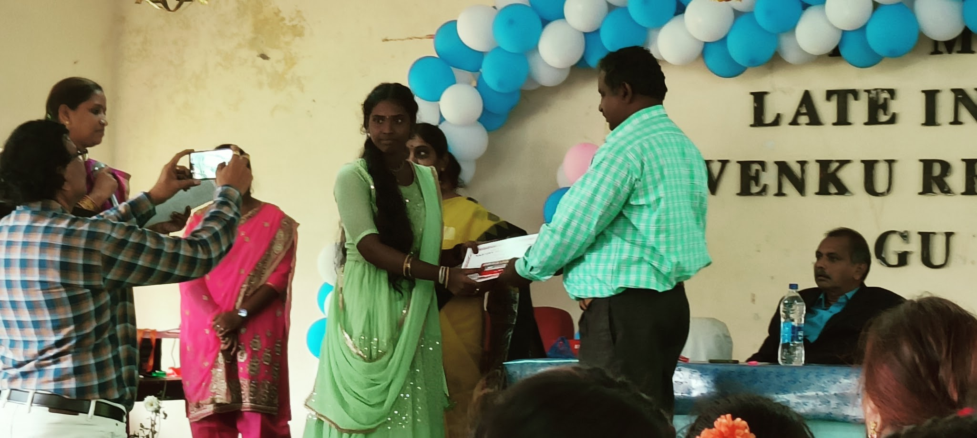
Prize Distribution by Vice Principal garu for Meritorious Students on occasion of SIP

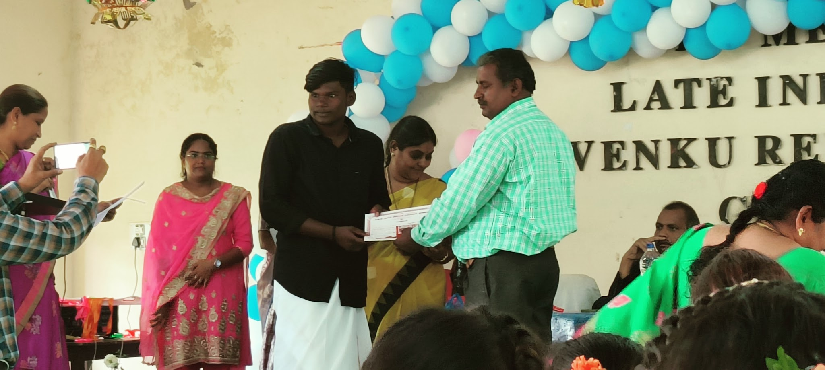
Prize Distribution byVice Principal garu for Meritorious Students on occasion of SIP

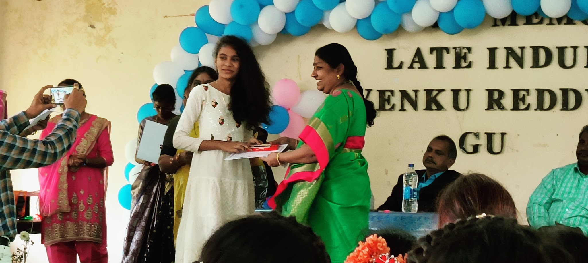
Prize Distribution by Dr.Jhansi Vani Lecturer In Telugu garu for Meritorious Students on occasion of SIP

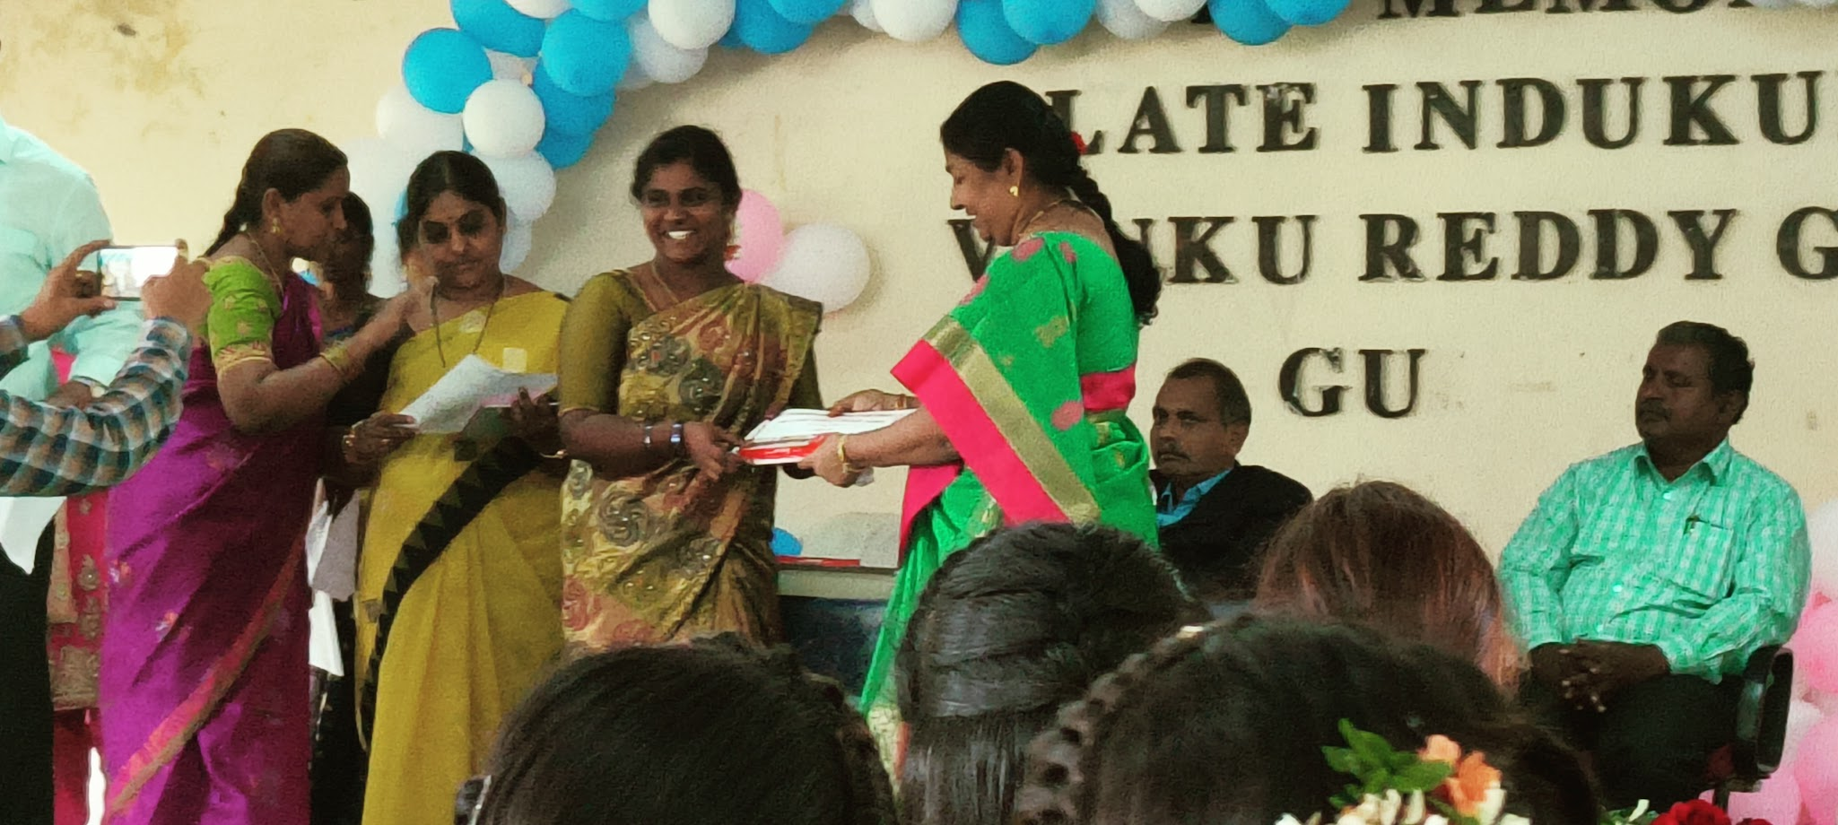
Prize Distribution by Dr.Jhansi Vani Lecturer In Telugu garu for Meritorious Students on occasion of SIP

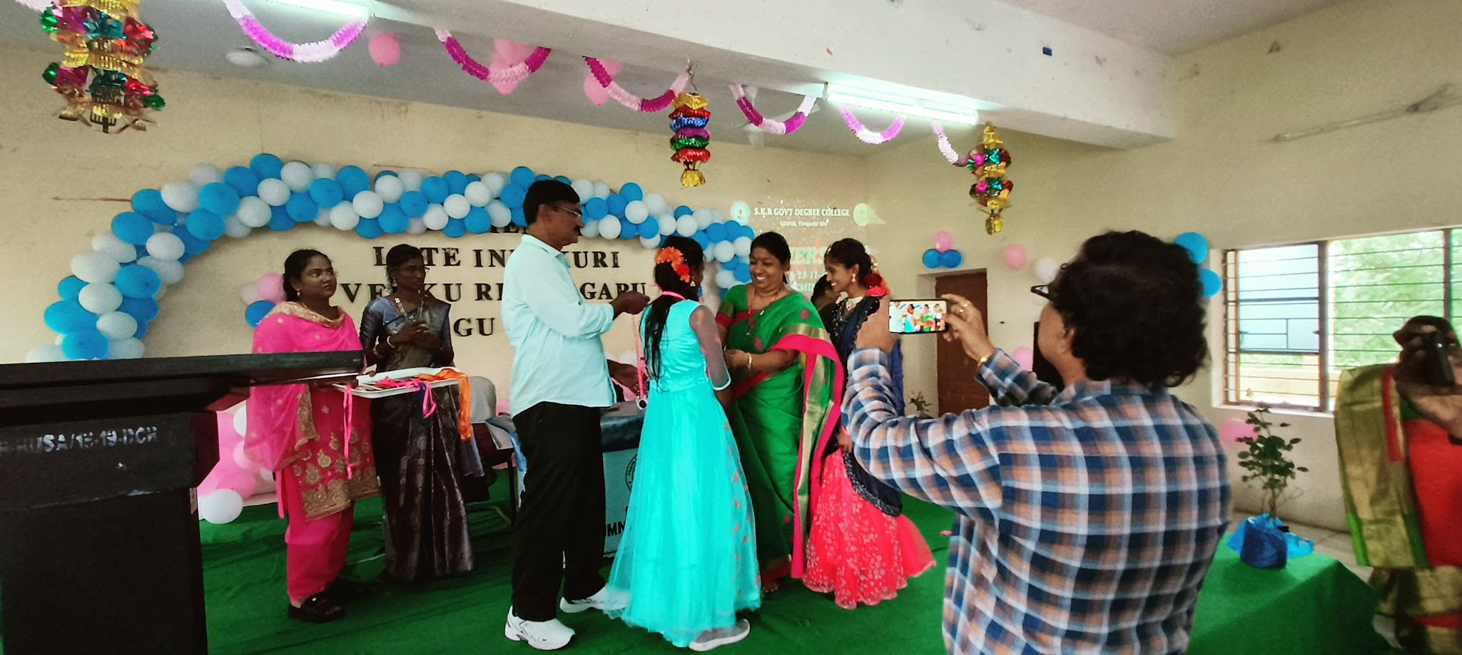
Prize Distribution by Dr.Jhansi Vani Lecturer In Telugu garu for Meritorious Students on occasion of SIP

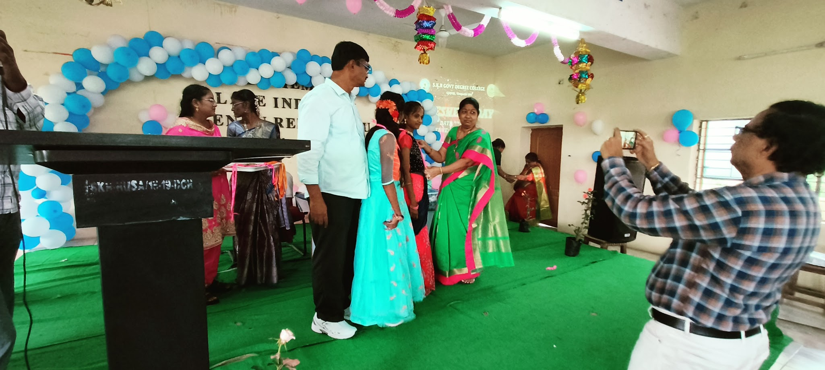
Prize Distribution by Dr.Jhansi Vani Lecturer In Telugu garu for Meritorious Students on occasion of SIP

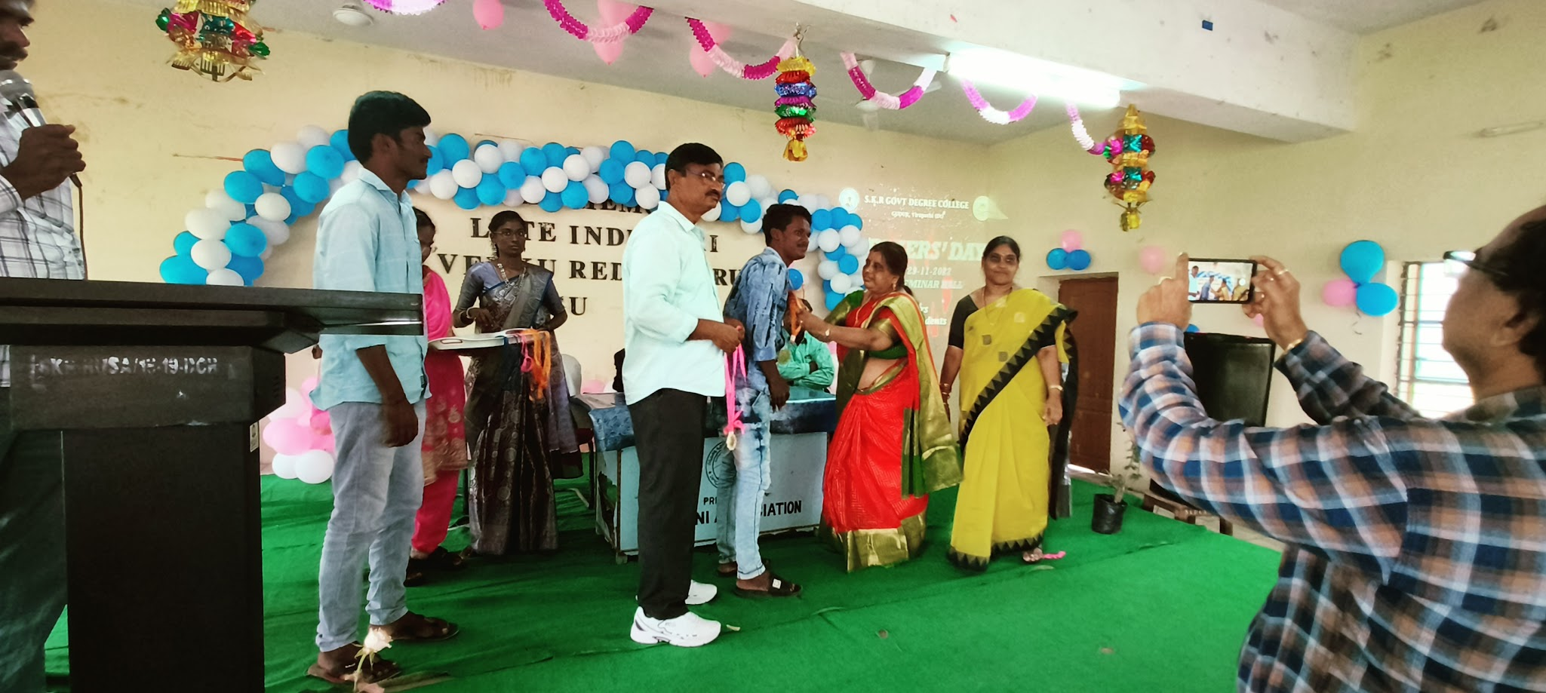
Prize Distribution bySmt Sailaja garu Lecturer In Commerce

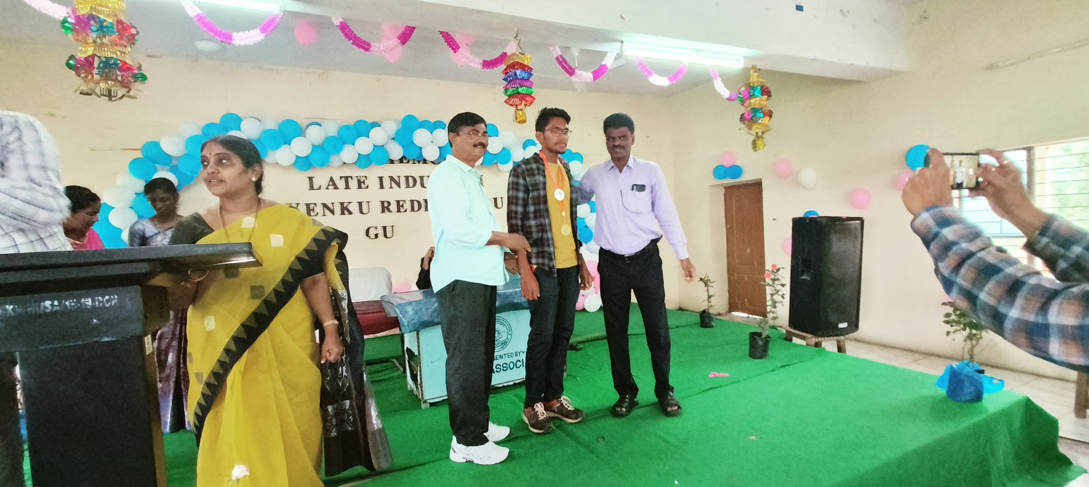
Medal Distribution by Dr.Narayana Raju garu & Dr.Siva Prasad garu for Meritorious Students on occasion of SIP

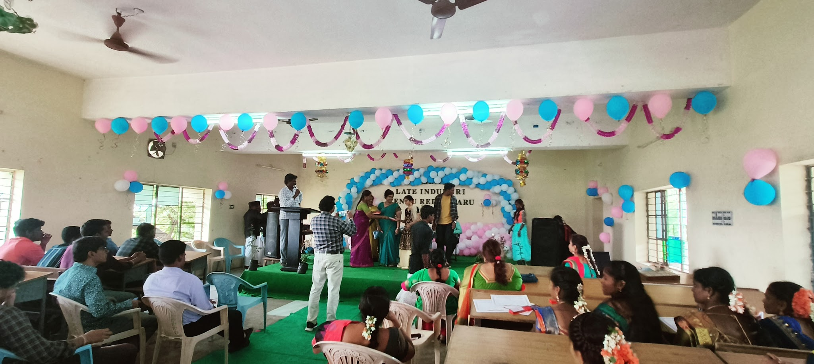
Prize Distribution by Smt B.Lakshmi Rambabu Lecturer In Computer Science for Meritorious Students on occasion of SIP

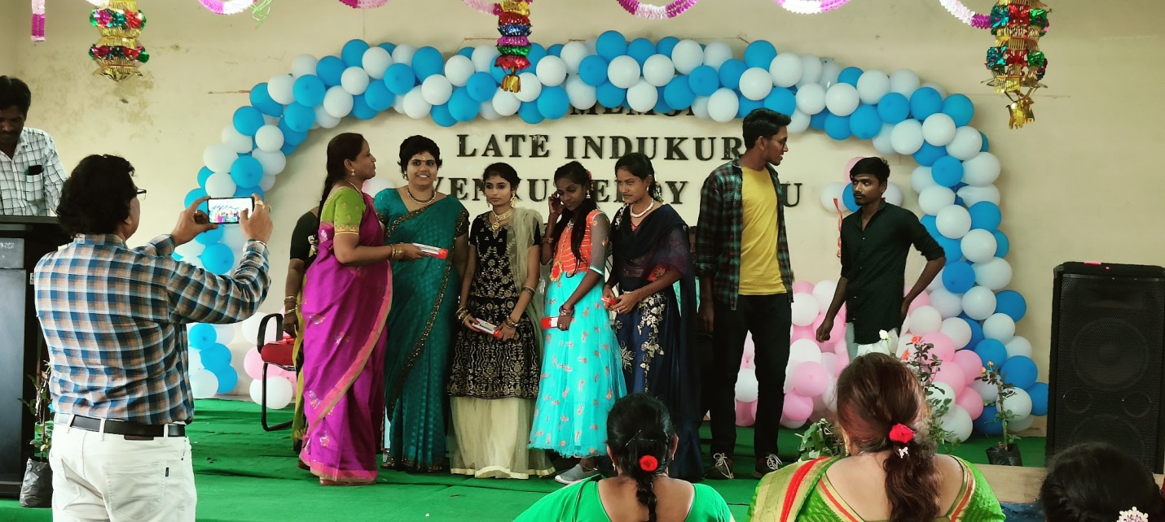
Prize Distribution by Smt B.Lakshmi Rambabu Lecturer In Computer Science for Meritorious Students on occasion of SIP

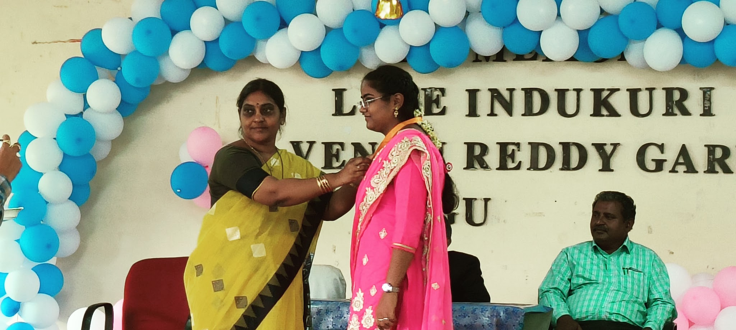
Prize Distribution by Smt S.Kiranmayee Lecturer In Mathematics for Meritorious Students on occasion of SIP

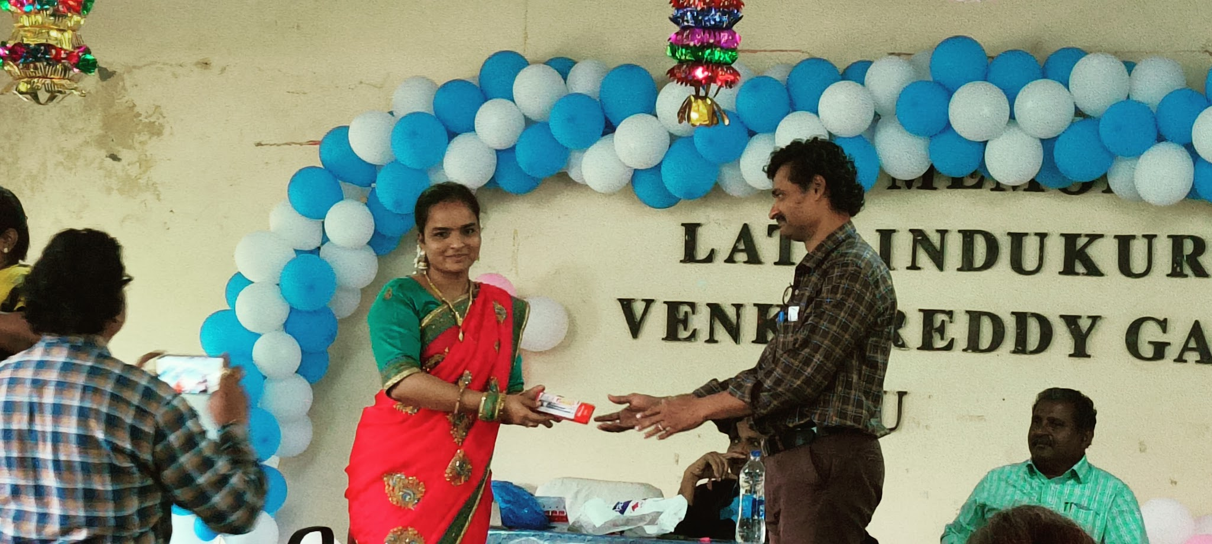
Prize Distribution by Smt SK.Mymoon Lecturer In Computer Science toSri B. Peera Kumar Lecturer In Economics

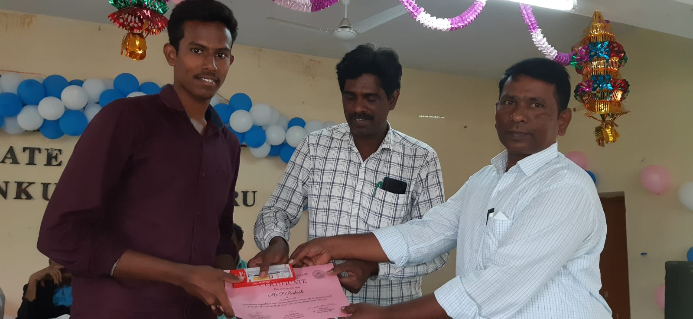
Prize Distribution by Sri Ravi Raju Garu Lecturer In Political for Meritorious Students on occasion of SIP

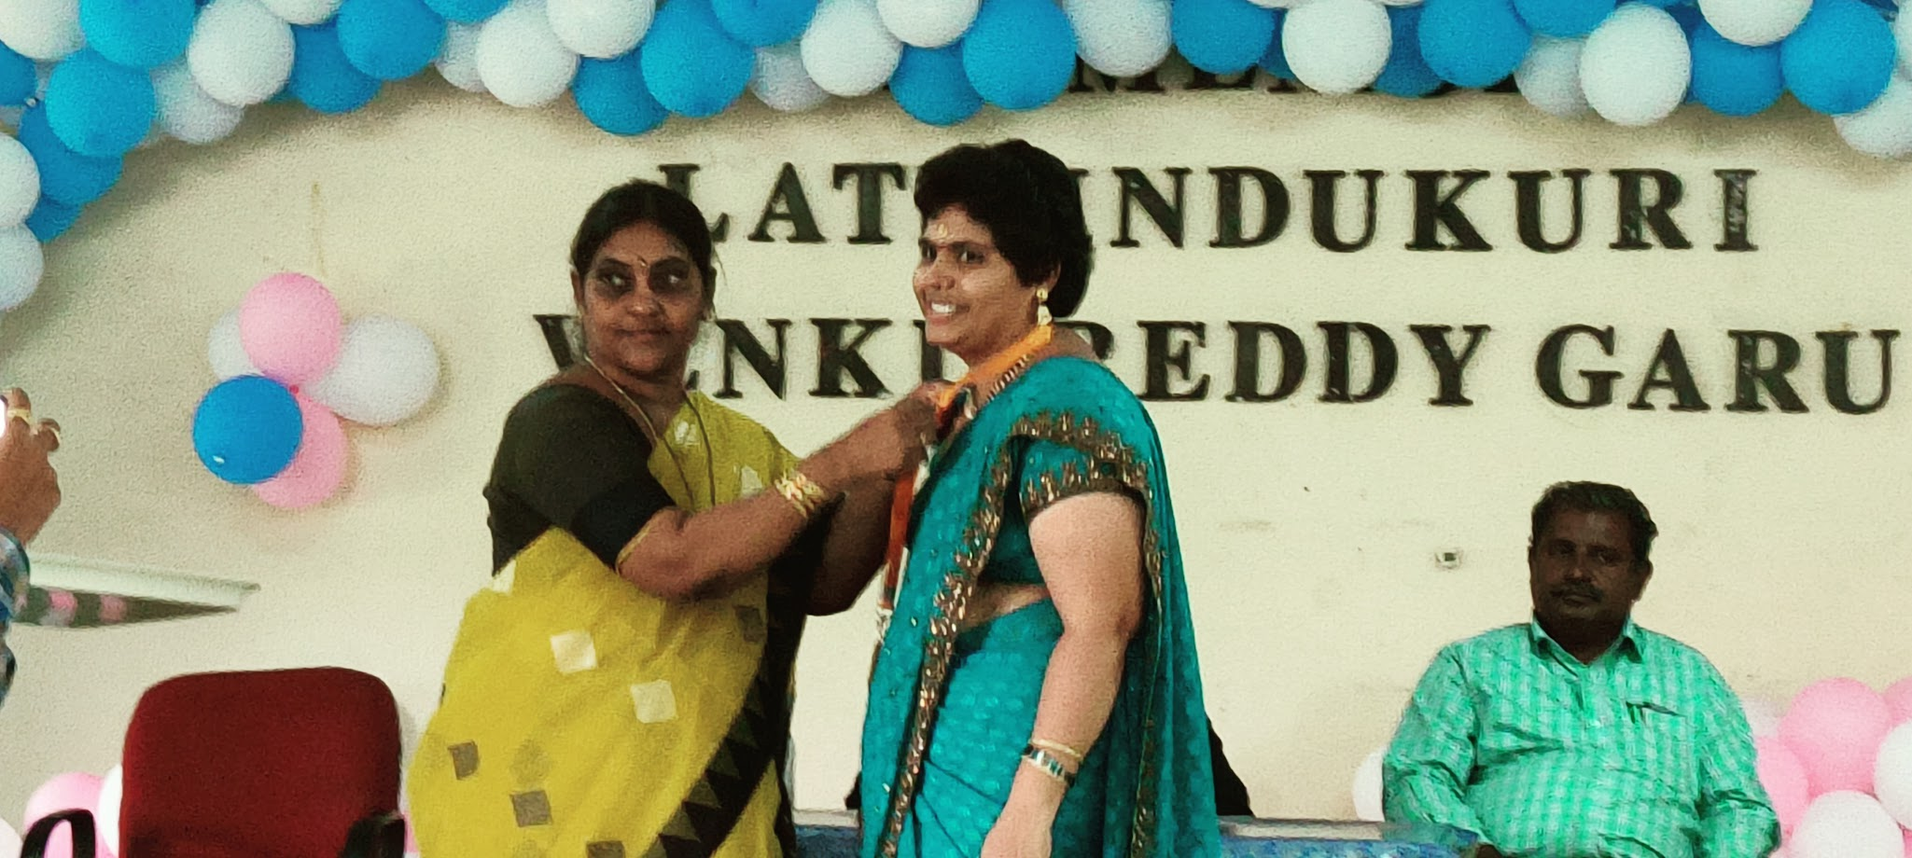
Prize Distribution by Smt S.Kiranmayee Lecturer In Mathematics for Meritorious Students on occasion of SIP

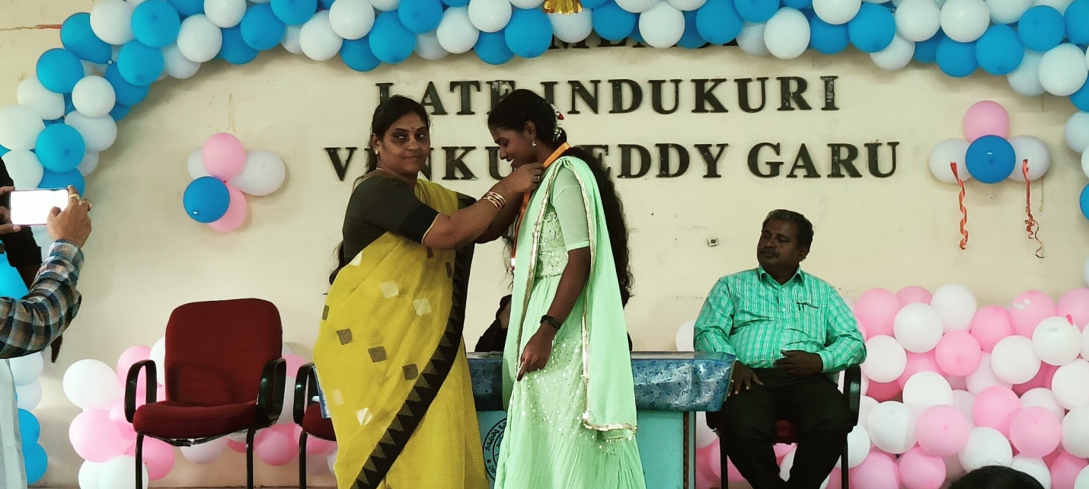
Prize Distribution by Smt S.Kiranmayee Lecturer In Mathematics for Meritorious Students on occasion of SIP

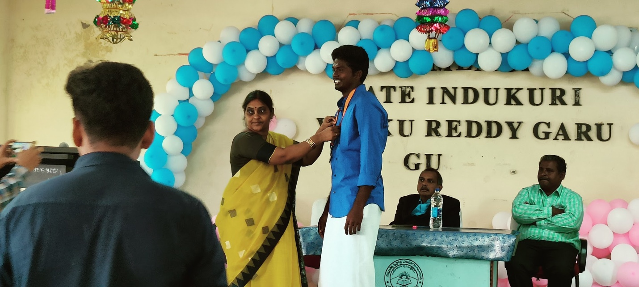
Prize Distribution by Smt S.Kiranmayee Lecturer In Mathematics for Meritorious Students on occasion of SIP

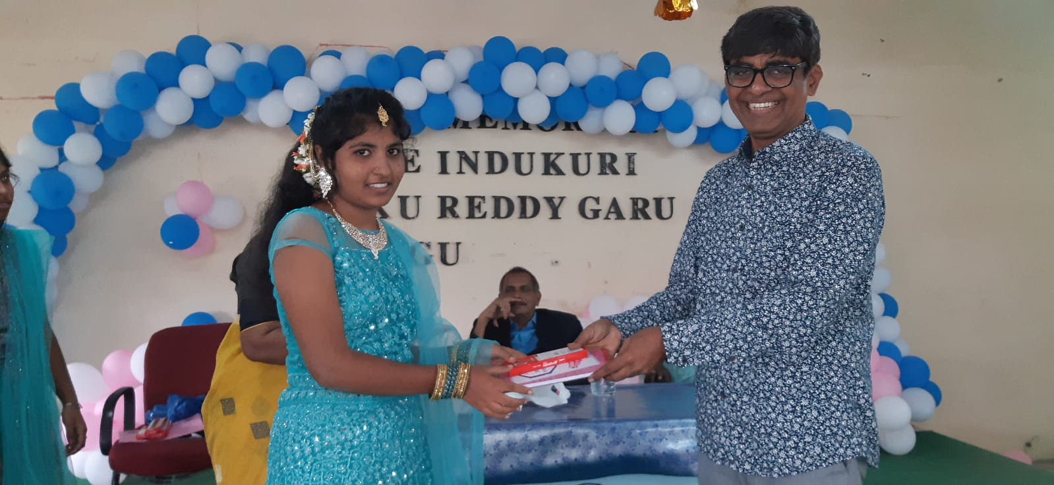
Prize Distribution by Dr.Koteswara Rao Lecturer In English on occasion of SIP
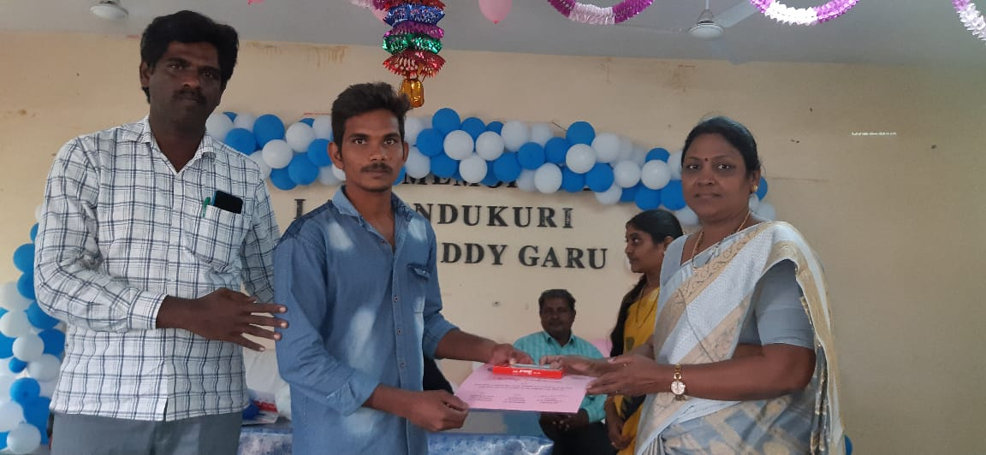
Prize Distribution by Smt Lakshmi garu Typist on occasion of SIP

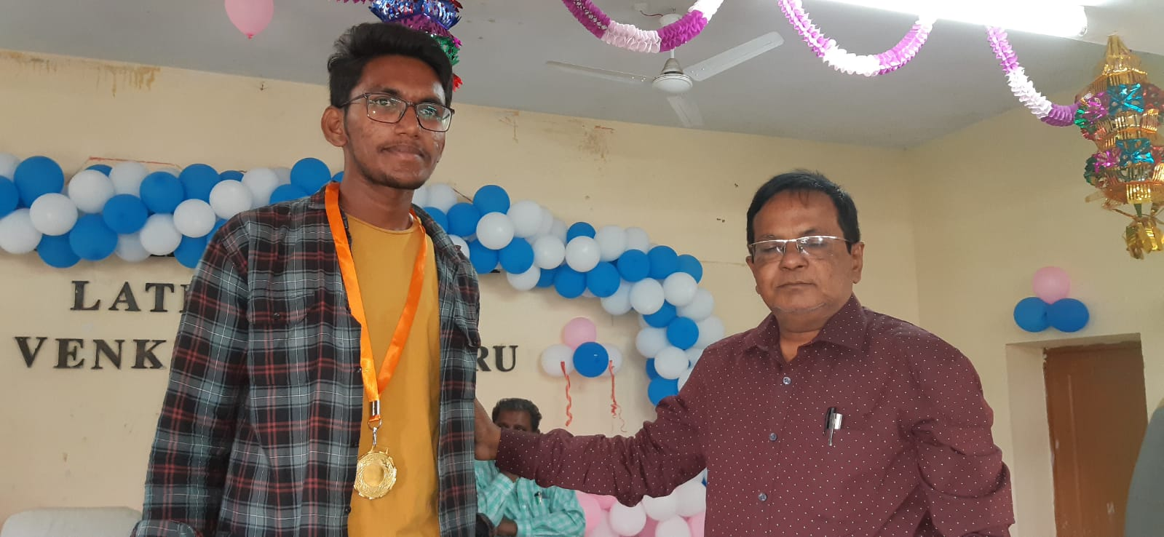

Prize Distribution by Dr.Vallinath garu Lecturer In Chemistry
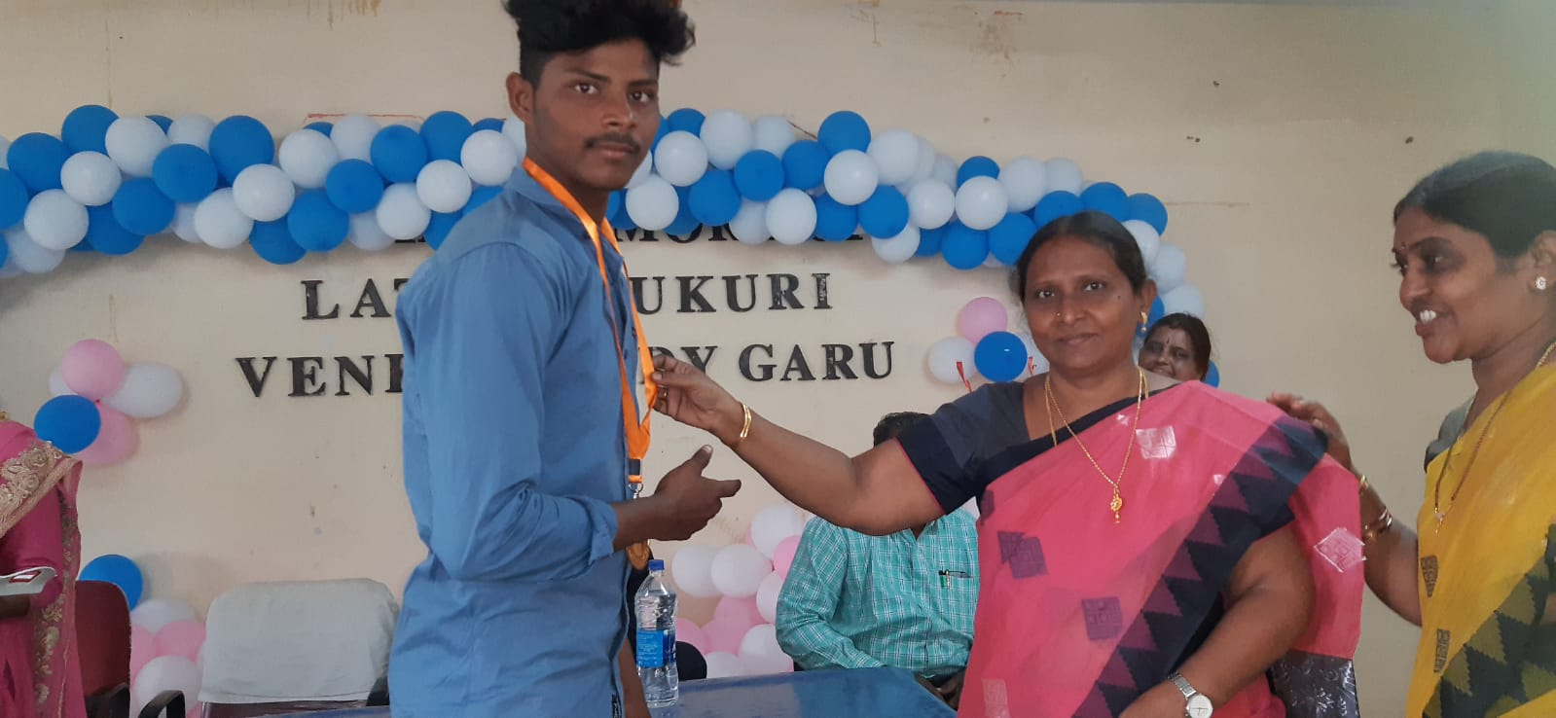
Prize Distribution by Smt Krupa Karuna Vani Lecturer In Chemistry

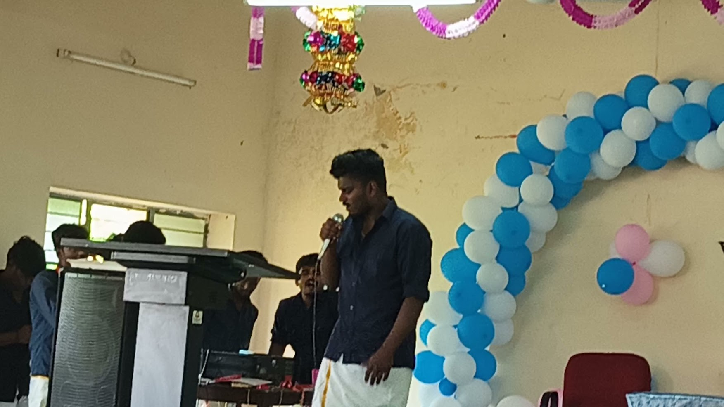
Feed back by students on occasion of SIP
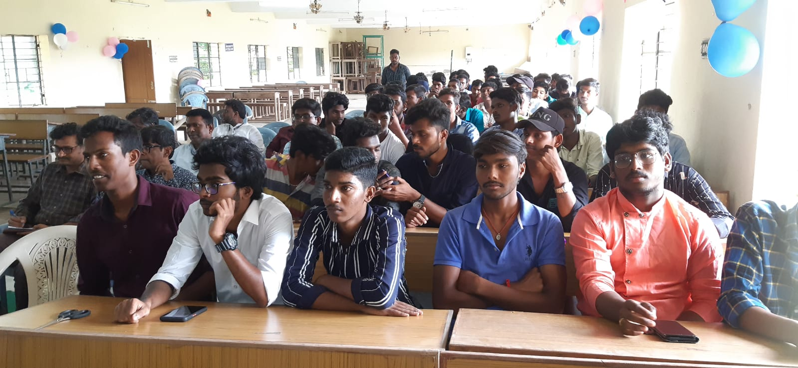
Students gathering on occasion of SIP

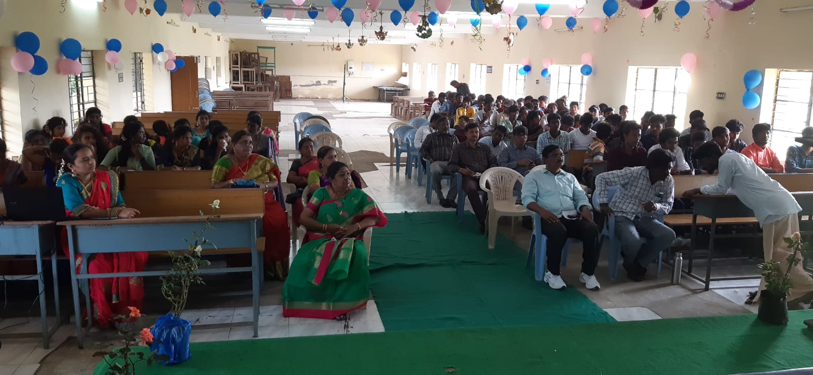
Students &Staff gathering on occasion of SIP

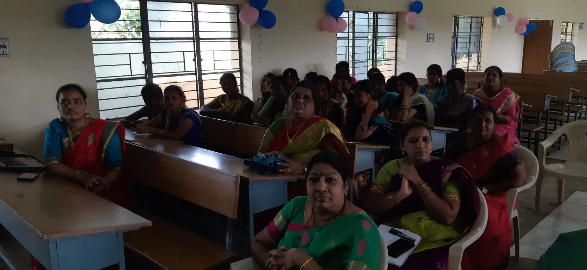 Students&Staff gathering on occasion of SIP

